34, VISHALA ESTATE, S.P.RING ROAD,OPP.ODHAV TO NIKOL ROAD, NIKOL, Ahmedabad, Gujarat, 382350
GST NO:-:24ARDPD2565K1ZX


info@torqpackagingsolution.com
www.torqpackagingsolution.com
An ISO 9001:2015 certified

Date: - 19/07/22
To.
M/S Newtrack
+91 81605 13376
Sub: - Automatic Powder Packing Line
Dear Sir,
Many thanks for your valuable inquiry of above subject. TORQ PACKAGING Solutions Is engage in making preliminary Bottle Packaging machines like bottle filling , capping , labeling, Automation, etc… in Ahmedabad, We are having dedicated team for manufacturing, customized machine development, Sales, servicing and back office.

Thanks & Regards
Ronak Dave
+91 80000 3128

Machine type | Quantity | Price
Automatic 2 head powder filling machine(servo base) | 1 | 5,10,000/-
Automatic 1 head capping machine | 1 | 2,30,000/-
Automatic sticker labeling machine | 1 | 2,40,000/-
Screw feeder | 1 | 1,80,000/-
Total | 4 | 11,60,000/-

Require change parts | Quantity | Price
Star wheel and back guide for capping (required for each bottle size ) | 1 | 12,500/-
Cap chute (required different height and dia) | 1 | 8,000/-
Vibrator bowl (require if different dia ) | 1 | 18,000/-

`
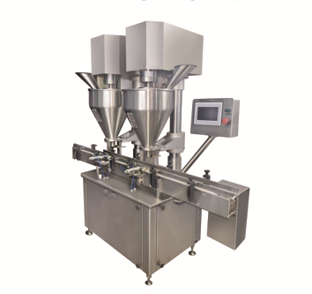

Description
Automatic Auger type Powder filling machine is precision built on sturdy welded SS frame completely enclosed in stainless steel sheet and doors are provided to facilitate the servicing of machine. The unit is made compact, versatile and enclosed in stainless steel elegantly matt finish body.

Operation
The dried, sterilized and siliconised bottles are fed through the infeed Turn Table on the infeed SS/Delrin conveyor belt at the required speed for feeding. When bottle reaches under the filling head, it is held by the pneumatic bottle holder. Immediately it is be sensed by the bottle sensor and gives signals to Servo to start to rotate which is mounted on auger shaft. It will fill the desired amount of powder to the bottle through auger, where rotation time is set in the Timer. After filling of first bottle pneumatic bottle holder releases the first bottle to move on conveyor for next operation.
Technical Specifications
Fill Size*** |  |  | 5 Gms to 500 Gms
Output/Hour* |  |  | 1500-3500 containers
Number of head |  |  | 2 No.
Electrical Specifications** | Main Machine |  | 1.5 HP / 415Volts / 50 Hz.
 | Conveyor |  | 0.25 HP / 415 Volts / 50 Hz.
 | Servo Motor |  | 750 Watt
Machine Dimensions** |  |  | 2000 mm (L) x 1100 mm (W) x 1700 mm (H)
Net Weight |  |  | 480 Kgs.
Change parts required |  |  | (a) Auger (b) Funnel
Input Specificaction
Container Neck Diameter** |  |  |  | Minimum 22 mm***
Container Size** |  | Round Shape |  | Ø 28 mm to Ø 100 mm  Respectively height 58 mm to 240 mm  (Height option for other bottle height available)
 |  | Flat / Square |  | 15 mm to 100 mm (Length)  Respectively 10mm to 50 mm (Width)  Respectively height 58 mm X 240 mm  (Height option for other bottle height available)
* Depends on Container size, fill size, Neck diameter of container, and nature of liquid etc.
** We can supply as per customer requirements.
*** With help of change parts.
Salient Features
- Automatic with filling range from 5 Gms to 500 Gms
- No container no fill system
- Accuracy ± 3 % in single doze.
- Body covered with SS sheet.
- All contact parts SS 316.
- A unit to fill variety of fine and granulated powder and can be used for various type of containers.
- Minimum change over time of change parts
- Servo PLC based operation

Utility Requirement
Electrical supply |  |  | 3 Phase + Neutral + Earthing
Electric load |  |  | 2 kw
Air |  |  | 6 KG max

Automatic Single Head CTC/Screw Capping Machine

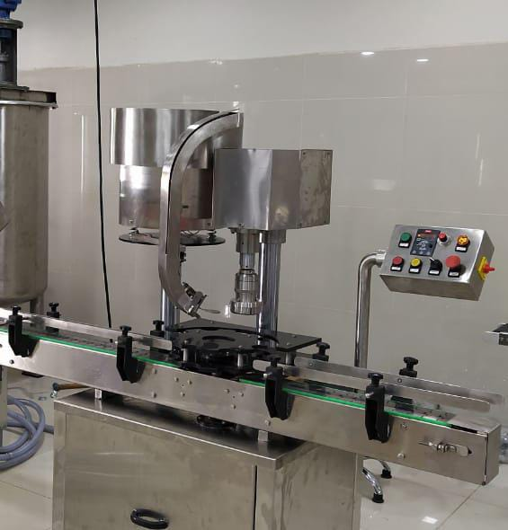
Description
Automatic Screw cap sealing machine is versatile, self-supported on stainless steel leg with height adjustable adjustment system. The machine is precision built on sturdy welded steel frame completely enclose in stainless steel sheet and doors are provided to facilitate the servicing of machine

Operation
The feed container moving on conveyor belt are fed into star wheel, bringing the container below the sealing head in the subsequent indexing part, meanwhile the bottle pick up a cap from the delivery chute of cap feeding bowl, where the body and the neck of the container are positioned below the rotating head, where the sealing head is performing perfect operation of capping.
Technical Specifications
Output/Hour* |  |  | 1000 to3000 bottles
Direction of Movement |  |  | Left to Right
No. of Sealing Head |  |  | 1 Nos.
Power Consumption | Main Motor |  | 1 HP / 415 Volts / 50 Hz.
 | Cap Feeding Bowl |  | 300 watt, Magnetic coil
Height of Conveyor |  |  | 860 mm to 910 mm
Machine Dimensions** |  |  | 2000 L x 1100 W X 1700 H
Case Dimensions |  |  | 2150 mm (L) x 1150 mm (W) x 1800 (H) Approx.
Net Weight |  |  | 350 Kgs. Approx.
Gross Weight |  |  | 500 kgs.
Change parts required |  |  | - Container: Star Wheel, Back Guide, Feed Worm  - Cap Die, Delivery Chute, Bowl
Input Specification
Screw Cap | Diameter** |  | 19 mm to 38 mm***
Specification | Height** |  | 15 to 18.3 mm
Container Size** | Round Shape |  | Ø 28 mm to Ø 100 mm  Respectively height 58 mm to 240 mm  (Height option for other bottle height available)
 | Flat / Square |  | 15mm to 100 mm (Length)  Respectively 10mm to 50 mm (Width)  Respectively height 58 mm x 240 mm  (Height option for other bottle height available)
* Depends on bottle size, cap size and type of cap.
** We can supply as per customer requirements.
*** With help of change parts.
Salient Features
- No container No cap arrangement.
- SS elegantly matt finished body.
- Single motor synchronizes conveyor, star wheel.
- Adjustable height of conveyor belt, to align with other machine of the line.
- Sealing pressure can be varied to suit different gauges and size of caps.
- Low noise level, low power consumptions.
- Self-lubricating UHMW-PE guide profile for low friction wears surface, smooth and noiseless conveying.
- SS cladding or hard chrome plating of all exposed parts to ensure long life and resistance against corrosion.
- Synchronized A/C drives to synchronize, Conveyor, Star wheel and Platform turret & capping bowl.
- Adjustable bottle height gauge for easy and quick setting.
Utility Requirement
Electrical supply |  | 1 Phase + Neutral + Ear thing
Electrical load |  | 0.75 KW

Automatic sticker labeling machine for round bottle
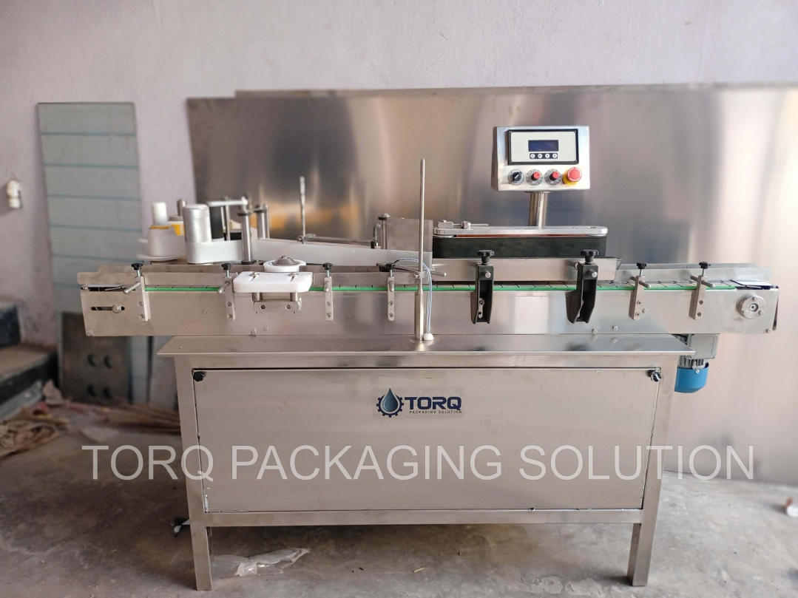
Description
The Automatic Vertical Sticker Labeling Machine is one of the most users friendly. The machine is used for full/partial labeling on different size of flat or rectangular containers. The automatic model is equipped with roller spacing device resulting in a simple operation with “No change parts required”.
Operation
The filled and sealed bottle is conveyed from the Conveyor and on the same conveyor one bottle separator attachment is provide to separate the bottle from continuous movement. A sensor provided to sense the product after sensing the sensor give command to operate steeper or servo motor to release label when one label is stick the gap sensor give command to stop the servo or stepper during releasing of label provision of brush to press the label & remove the air between label & bottle after completion of the cycle one operation of labeling is finish & conveyor bring the bottle for next operation..
Technical Specifications
Output/Hour* |  |  |  | 4000 to 6000
Direction of Movement |  |  |  | Left to Right
Controlling |  |  |  | Microprocessor base control
Power Consumption | Conveyor motor |  |  | 0.5 HP / 415 V / 50 HZ
 | Pressing device motor |  |  | 0.25 HP / 415 V / 50 HZ
 | Stepper motor |  |  | 60 kg / cm2
Height of Conveyor |  |  |  | 850 mm to 900 mm Adjustable
Machine Dimensions** |  |  |  | 1828 mm (L) x 610 mm (W) x 1200 (H) Approx.
Case Dimensions |  |  |  | 2000 mm (L) x 700 mm (W) x 1325 (H) Approx.
Net Weight |  |  |  | 350 Kgs. Approx.
Gross Weight |  |  |  | 600 kgs Approx.
Input Specification
Label Specifications |  | Length** |  | 240mm Max
 |  | Roll Diameter |  | Max 300 mm & ID 75 mm
 |  | Space between two label |  | Min. 3 mm anti clock wise
* Depends on Container size, fill size, Neck diameter of container, and nature of liquid etc.
** We can supply as per customer requirements.
Salient Features
- High Production Speeds.
- SS steel structure cladded with stainless steel 304 sheet to meet GMP norms.
- Microprocessor Based operation
- Accurate label placement.
- No change parts requirements.
- Very less down time for change over.
Utility Requirement
Electrical supply |  |  | 1 Phase + Neutral + Earthling
Electrical load |  |  | 1 KW

Automatic screw feeder
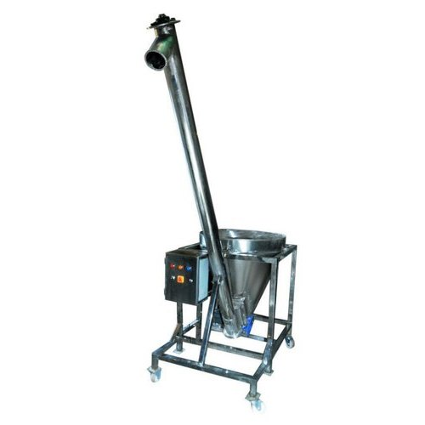
Description
Screw feeder, also known as semi automatic screw powder filler which is used to fill large size of powder continuously in hopper in a very short time.
Technical Specifications
Output/Hour* |  |  | 250 kg per hour
Direction of Movement |  |  | Down to Upword
Controlling |  |  | Microprocessor base control
Power Consumption | Conveyor motor |  | 1 HP
 | Stirrer Motor |  | 0.25 HP / 415 V / 50 HZ
Height of Machine |  |  | 3500 mm to 900 mm Adjustable
Machine Dimensions** |  |  | 700 mm (L) x 850 mm (W) x 1200 (H) Approx.
Net Weight |  |  | 250 Kgs. Approx.
Gross Weight |  |  | 350 kgs Approx.
Salient Features
- High Production Speeds.
- SS steel structure cladded with stainless steel 304 sheet to meet GMP norms.
- Microprocessor Based operation
- Variable Speed
- No change parts requirements.
- Very less down time for change over.
Utility Requirement
Electrical supply |  | 1 Phase + Neutral + Earthling
Electrical load |  | 1 KW

- Terms & Conditions

1 | PRICE | The prices mentioned are ex our Ahmadabad works
2 | TAXES & DUTIES | 18% extra
3 | TERMS OF PAYMENT | We agreed to have 50% advance and 50 % before Dispatch.
4 | DELIVERY  PERIOD | Within 3-4 Weeks from the date of receipt of technically & commercially clear order along with advance payment or receipt of approval for input dimensions, whichever is later
5 | INSURANCE | Transit Insurance against Theft, Pilferage, Breakage, Etc. will be arranged at extra cost at your explicit instruction, otherwise it will be assumed that goods are to be sent at your risk. Cost of such insurance will be as actual to be borne by the consignee.
6 | TRANSPORT | Transportation of the machine from our factory has to be arranged by you. We will arrange for loading of the equipment at our factory. However unloading at site has to be arranged by you. Our responsibility ceases once the goods leave our factory and are handed over to carrier. We do not undertake any liability for damage/ loss in transit whatsoever, whether the goods are insured or not. In case of any damage / accident during transit, the client has to directly deal with the insurance company without holding any payments, irrespective of the insurance arranged by Consigner or Consignee.
7 | INSPECTION | We offer inspection of the machine at our factory, by your technically competent representative, prior to dispatch. This person should be present on our factory during packing and loading of the machine. In case you are not deputing anyone for pre dispatch inspection, then we will not entertain any dispute arising out of short supply, quality, workmanship, functionality, operating parameter, etc. once the machine is dispatched.
8 | FACTORY  TRAINING | We will impart training to your operating staff in our factory before the machine is dispatched, at no additional cost. However, his lodging-boarding and local traveling expenses will have to be borne by you. This person should be technically competent to uncrate and assemble the machine at site before the arrival of our commissioning engineers. He must ensure that ground work necessary at site is competed in all respects before machine. Commissioning, He must be competent enough to be able to run the machine and carry out routine maintenance, once the machine is handed over after commissioning
9 | INSTALLATION | The machine has to be uncarted and placed in working position by you at site. You have to carry out all the external powers and air compressor at site. The machine must be available in the fully assembled condition when our commissioning engineer arrives at site.
10 | COMMISSIONING | For supervising and commissioning of the machine we will depute one of our engineers on chargeable bases. Customer will have to send a prior intimation of readiness of electrical and utility connections along with required materials.  Rs. 2,000/- per man day will be charged. Customer will reimburse to and for 1st class fare from  Ahmedabad to the destination, lodging and boarding expenses and other local expenses for the period of commissioning.
11 | SPECIFICATION | In line with our policy of continual improvements, we reserve The right to modify the design and change the specifications and make of any material, if in our opinion such modification leads to an improvement in the performance of the machine. Therefore specification, illustrations, dimensions, offers, drawings or photographs are not binding in detail.
12 | WARRANTY | Our goods carry a warranty of one-year trouble free operation from the date of dispatch. The warranty is only against manufacturing defect. It does not cover any electrical, electronic or bought out components.  Components getting normal wear and tear would be replaced at your cost.
13 | NOTE | Customer have to provide samples of bottles, caps, labels etc. along with the purchase order otherwise machine will be made as per our standard specifications, wherein we will take trial with water, caps, bottle, label etc available with us, which will be acceptable to you.
14 | CANCELLATON  OF ORDER | Order once placed, cannot be cancelled under any circumstances. In case of orders being cancelled, then the entire amount of advance payment will stand forfeited.
15 | OFFER VALIDITY | This offer remains valid for the period of 30 days. Any extension thereafter will be subject to our written confirmation only.
16 | JURISDICTION | No legal proceedings shall be taken to enforce claims and no suit arising out of any contracts shall be instituted except in a court of competent jurisdiction located within Ahmedabad, Gujarat.

